We will use JS to write Playwright code. So we need Nodejs.
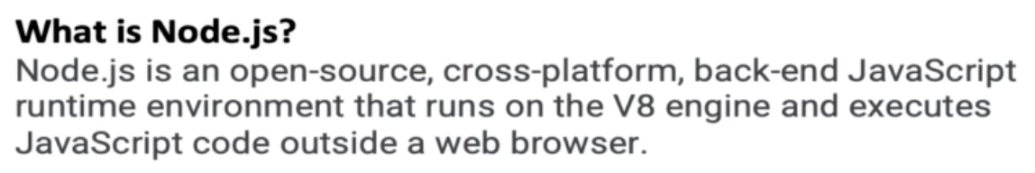
Just like we need JRE to run Java on our machine, similarly to run Javascript code, we need Nodejs environment. However, we can still run JS code inside our browser even without having Nodejs.

The reason you can run JavaScript in a browser without needing Node.js is because browsers come with their own built-in JavaScript engines. These engines interpret and execute JavaScript code directly within the browser.
For example:
- Chrome uses the V8 engine
- Firefox uses SpiderMonkey
- Safari uses JavaScriptCore (also called Nitro)
Install Nodejs

Search on Google for “nodejs install”.

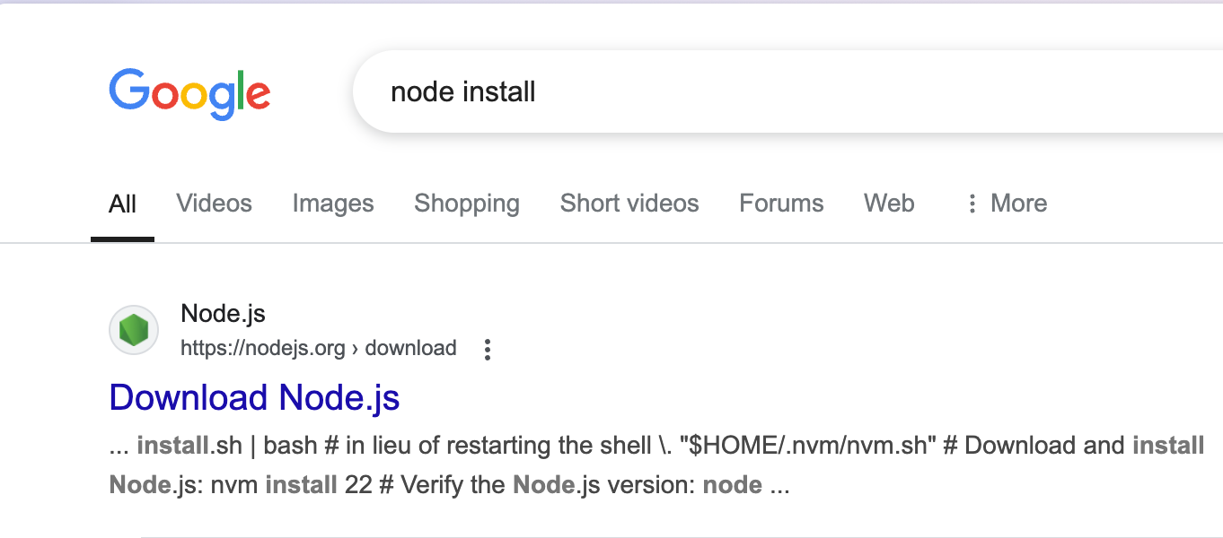
Go to their official website. Select the LTS version in top dropdown.

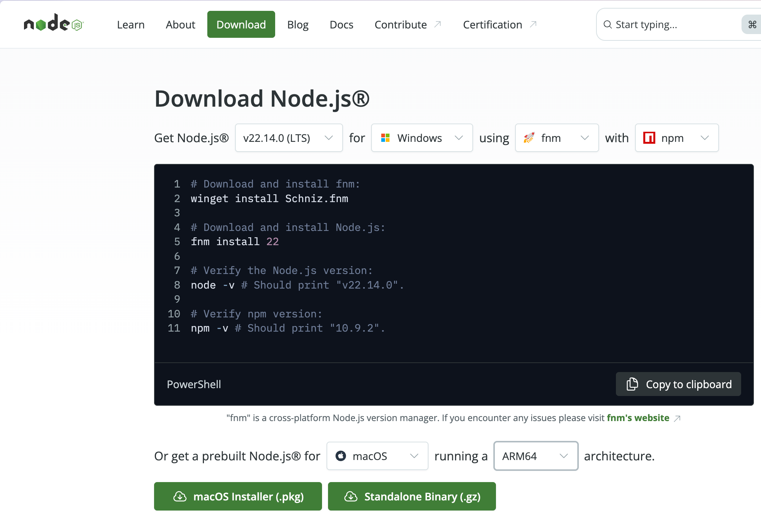

For Windows, you will see this but scroll down and just click the Windows Installer(.msi) button.

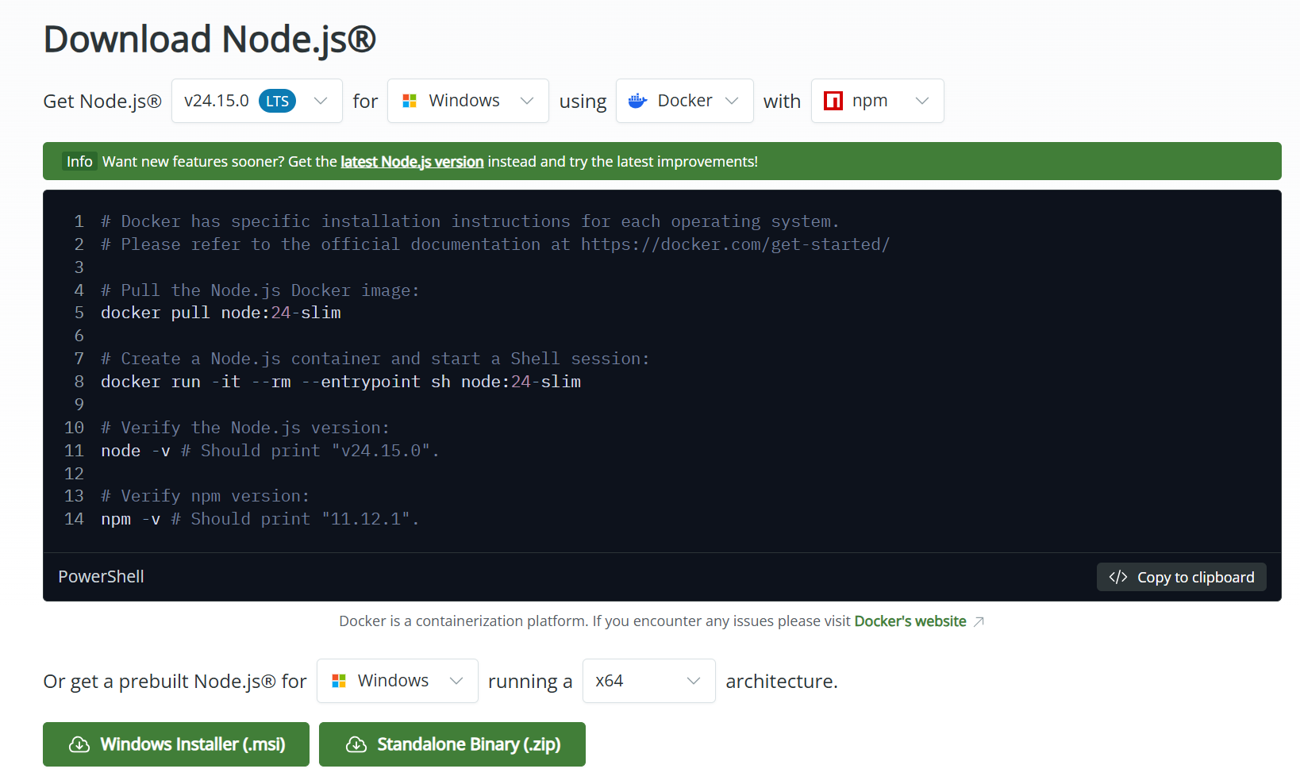
Expand the x64 architecture dropdown. You will see these options.
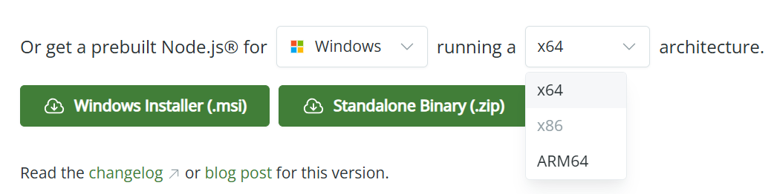

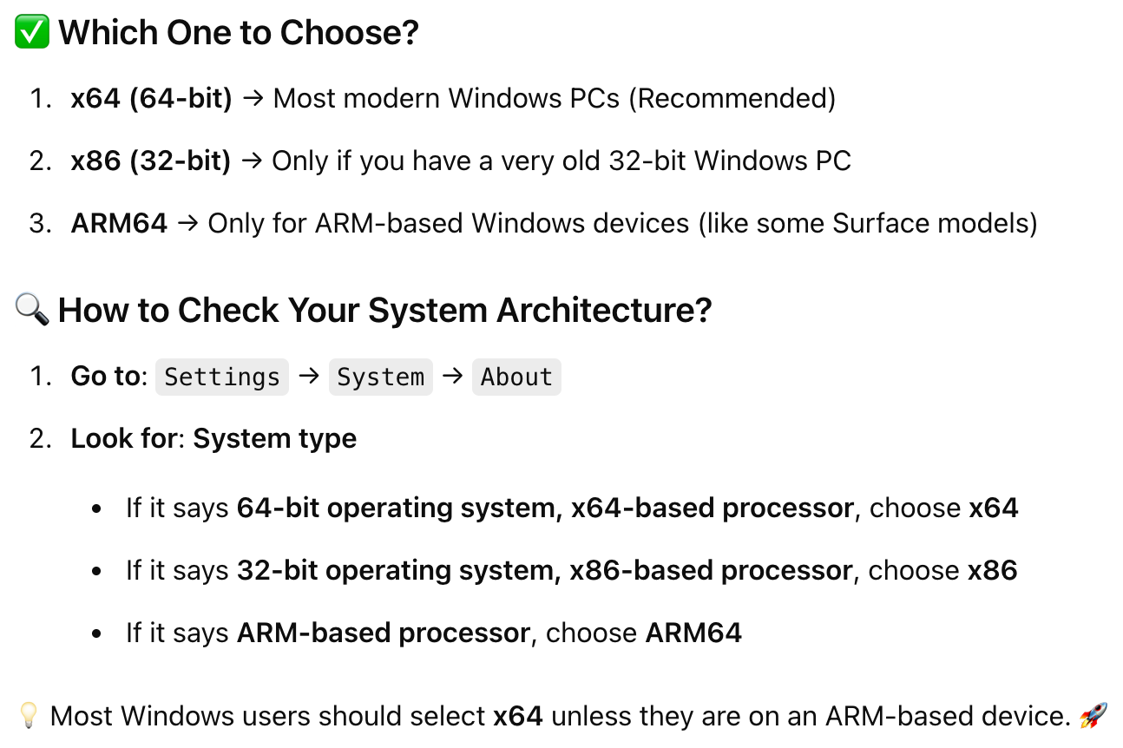
After clicking on the Windows Installer(msi) button, the file gets downloaded in the Downloads folder.

MAC Installation

Which option to choose for MAC?

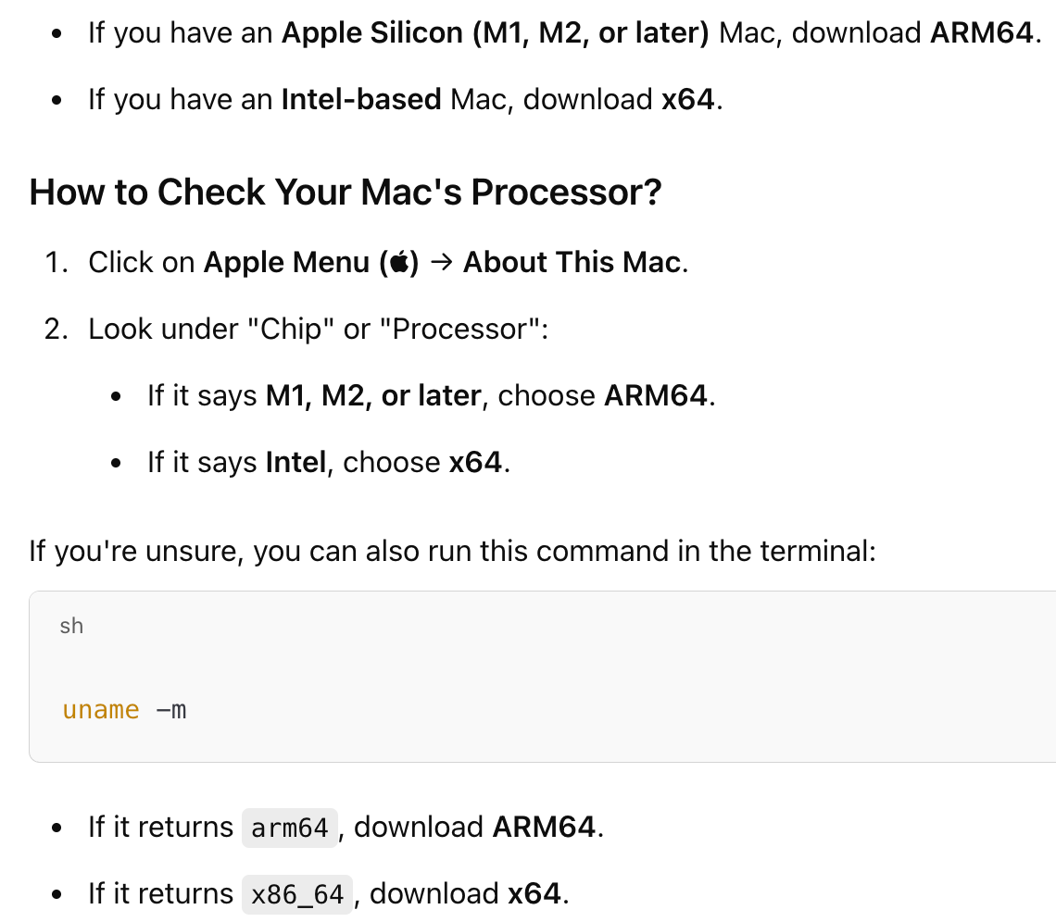

Click on the macOS Installer(.pkg) green button. The file will get downloaded.

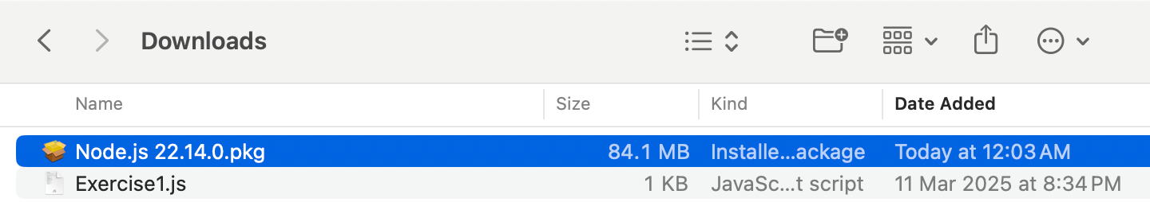

Double click on the pkg file.

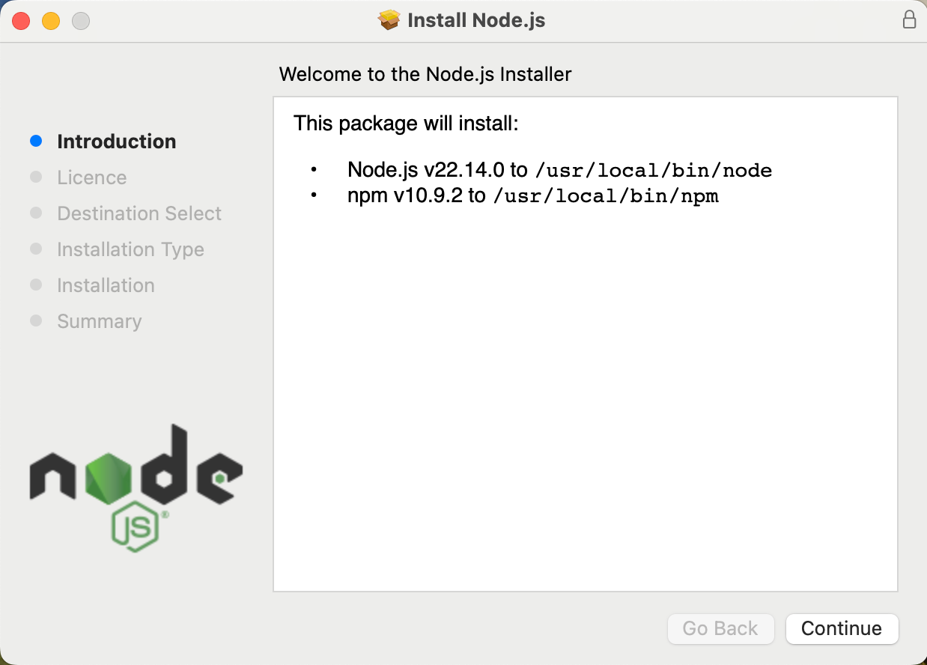

This package will install both Node.js and npm into the paths mentioned above.

Finally, after the installation, you will see this

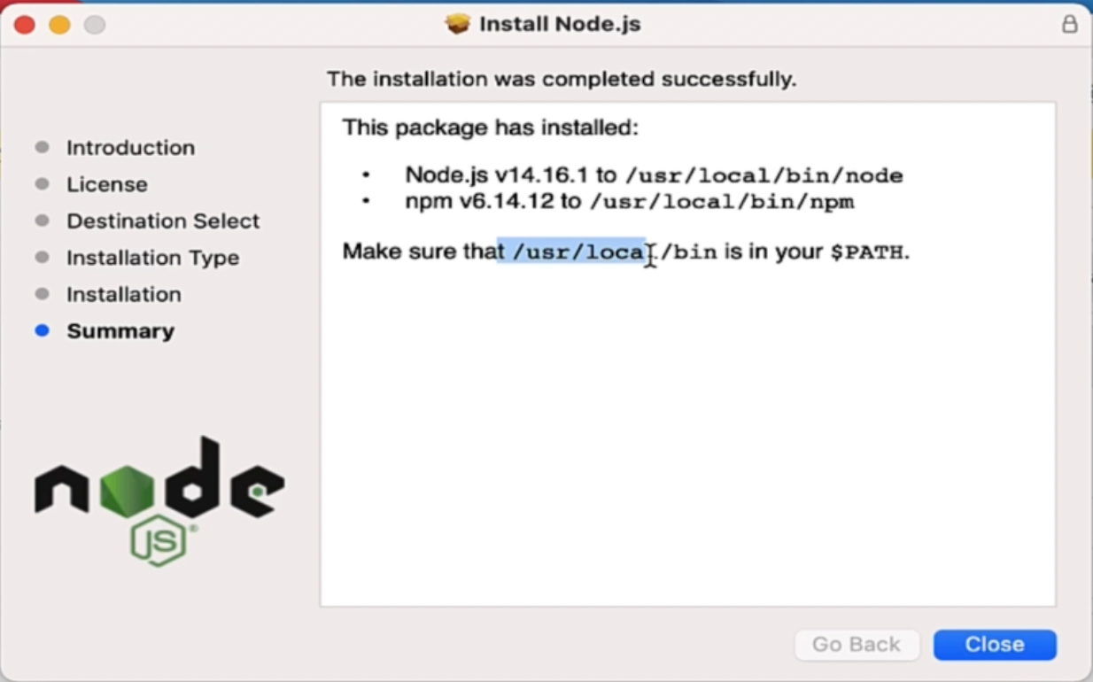

Download Nodejs LTS version for MAC. Now, we need to check if this path /usr/local/bin is in the path. Till it is added in the path variable, you can not use Nodejs globally.

Open Terminal and type - echo $PATH

I have this path already configured. Below is one path. Then we have “:” and another path and so on. Every path is separated by a colon. In most cases, it will be already there in most MAC machines so I don't need to add this path.

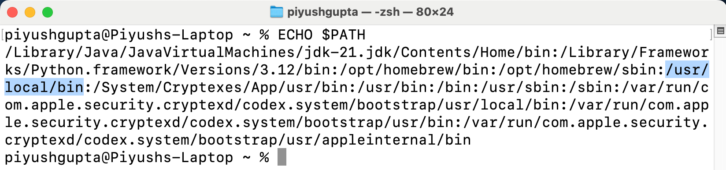
Only if you don't see this variable inside paths, then only you should add this variable.

Windows Installation

Open the Downloads folder.

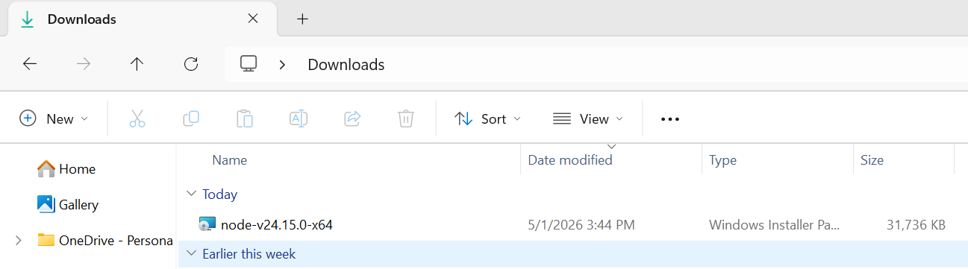
Double click on the file to open.

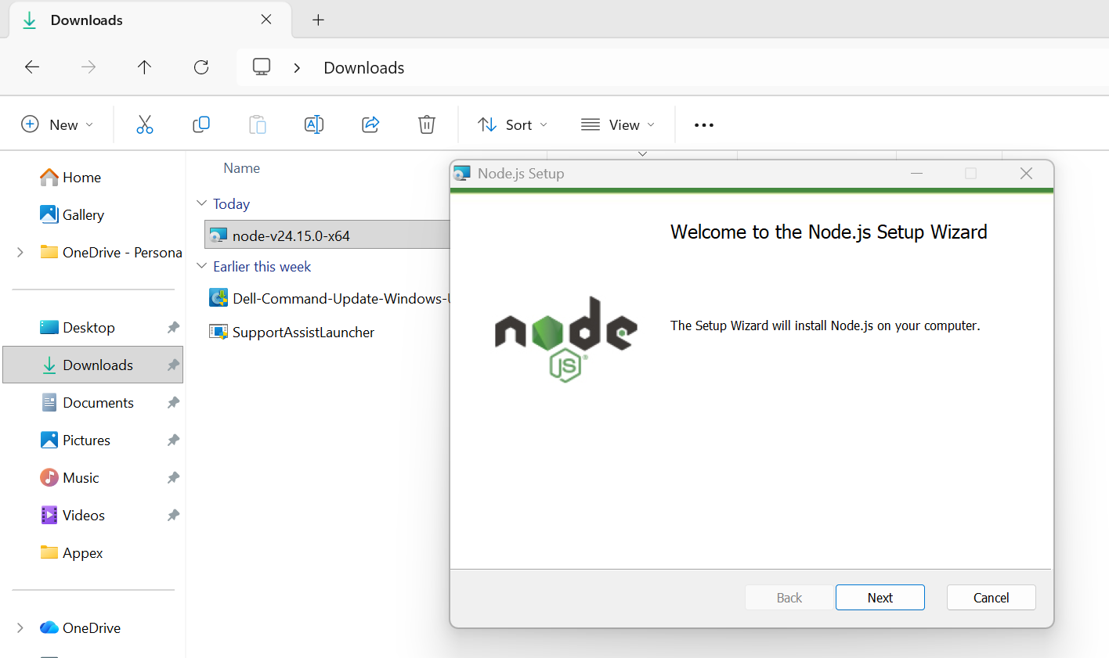

Click on the Next button.

Select the checkbox to accept the licence terms.

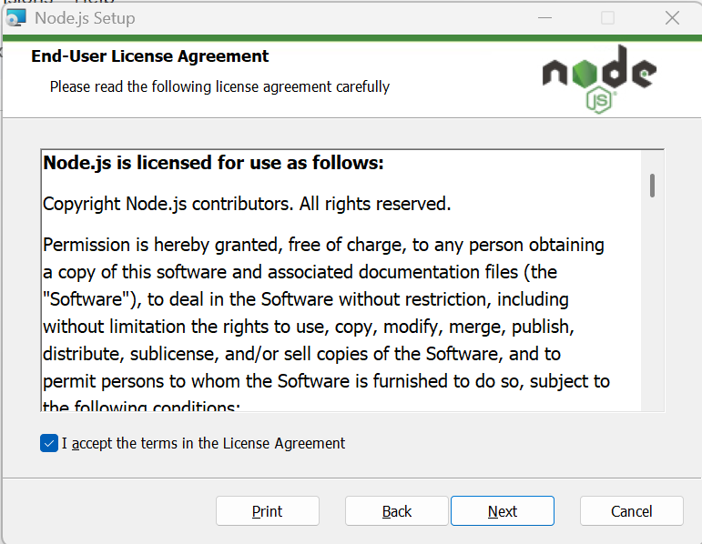

Click on the Next button.

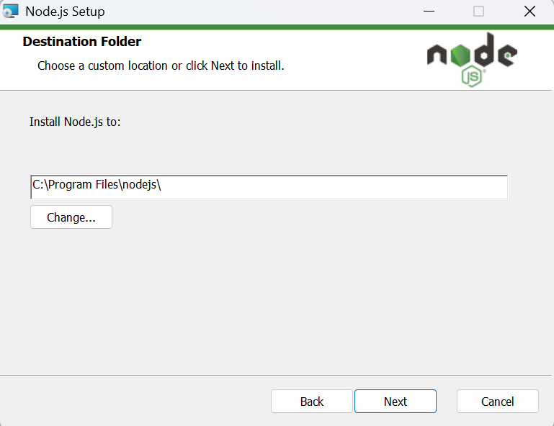

Click on the Next button.

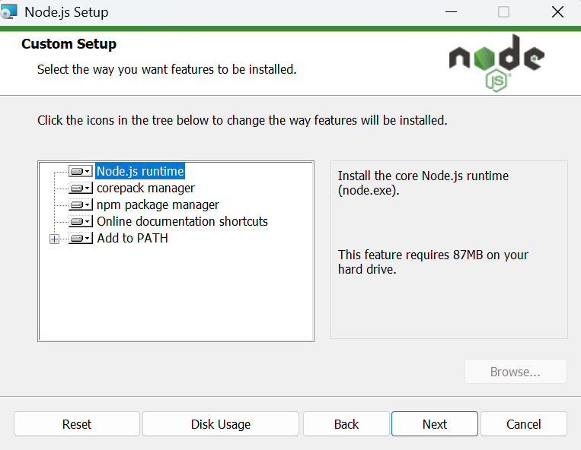
Do not change anything on this screen. Just click Next.
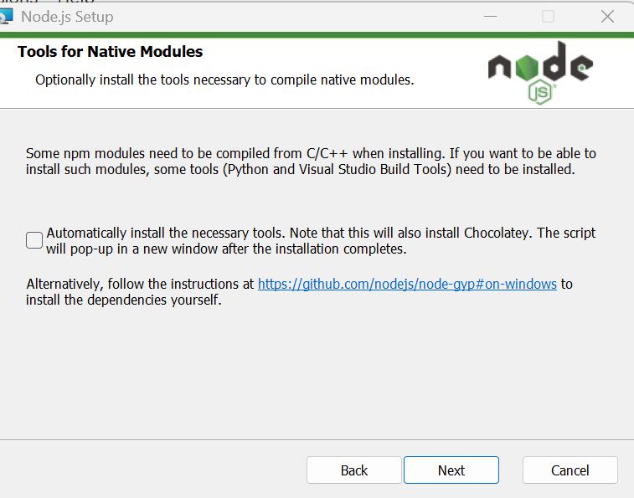
It is asking whether to install additional tools like:
- Python
- Visual Studio Build Tools
- Chocolatey
Most people learning JavaScript, Playwright, or automation testing do NOT need this.
Do not check this box. Just click Next.
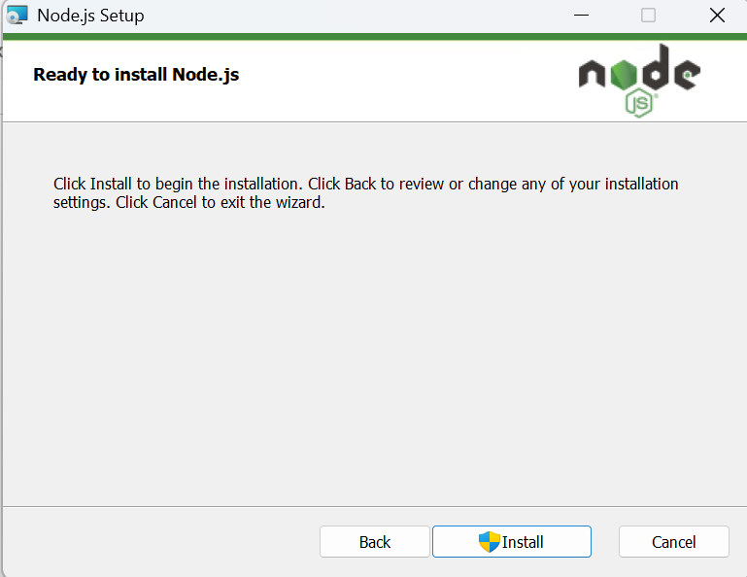
Click on the Install button.
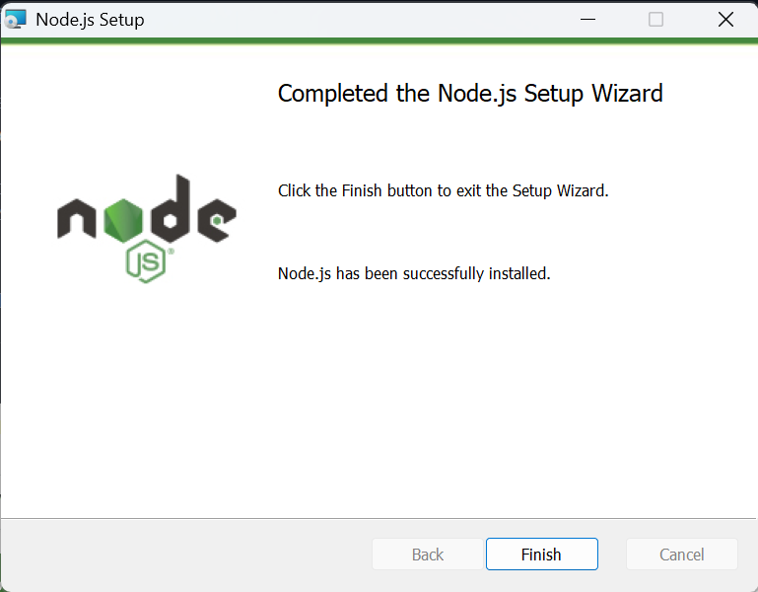
Click on the Finish button.
The next step is to verify the node installation.
Open the command prompt and run this command
node -v
npm -v
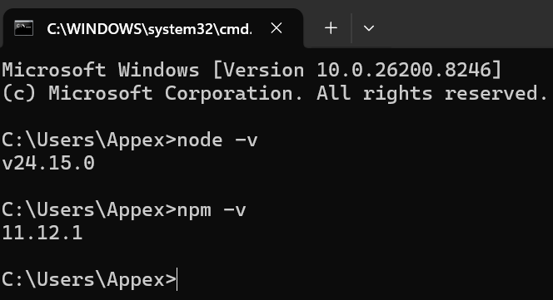

Now, since we are able to see versions for both these commands, it means node is successfully installed and path is automatically configured. No manual step is needed now.

In some special cases, you might see this message - node is not recognized as an internal or external command

If you get this message, you need to run the below steps.

Optional Steps

On Windows, after you install Nodejs, it gets installed in Program Files.

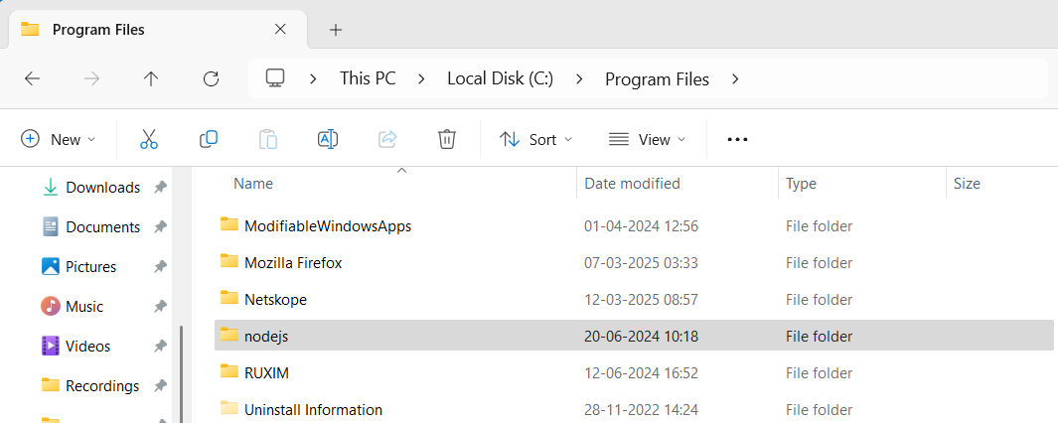

Copy the home path of Nodejs.

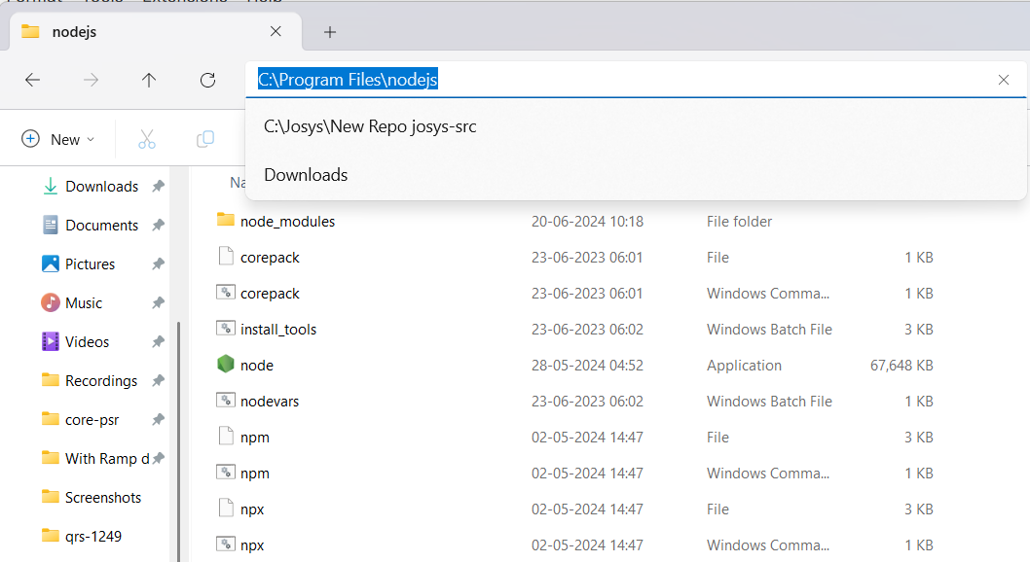

Then at the bottom, simply type “Edit” and open System Properties.

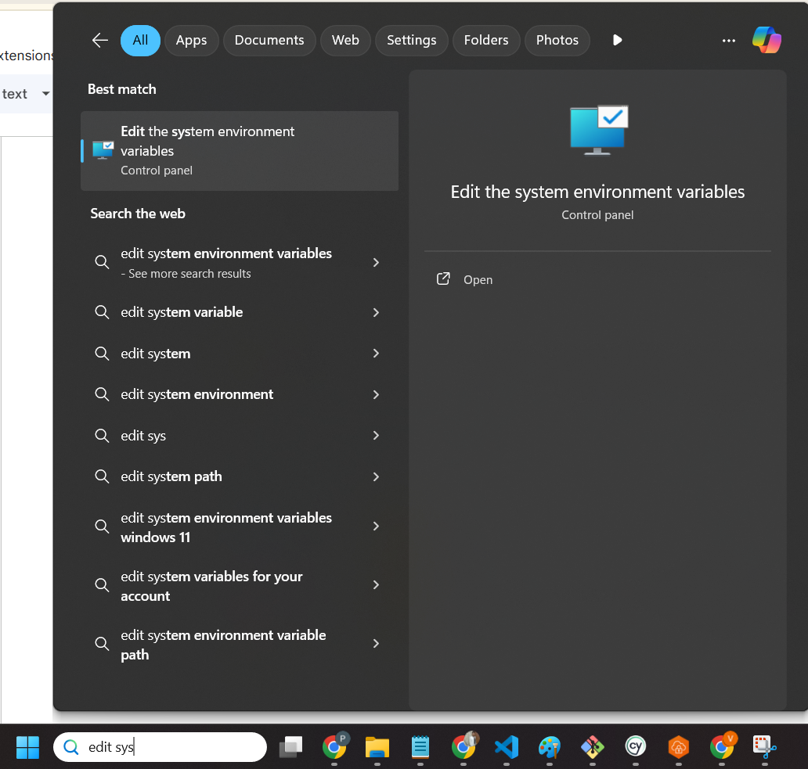

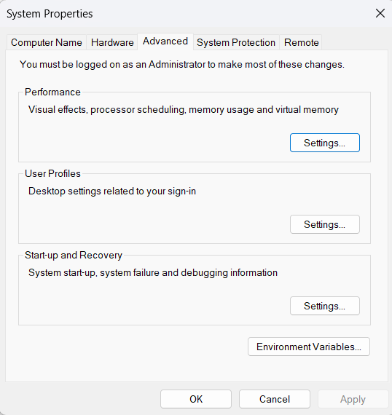

What we are doing is - We have nodejs installed on our machine and we also need to explicitly tell our system where it is located.

After setting the path, it will be available globally on our machine.

Click on the Environment Variables button.

Click on the New button inside the System variables section which will open a new dialog - New System Variable.

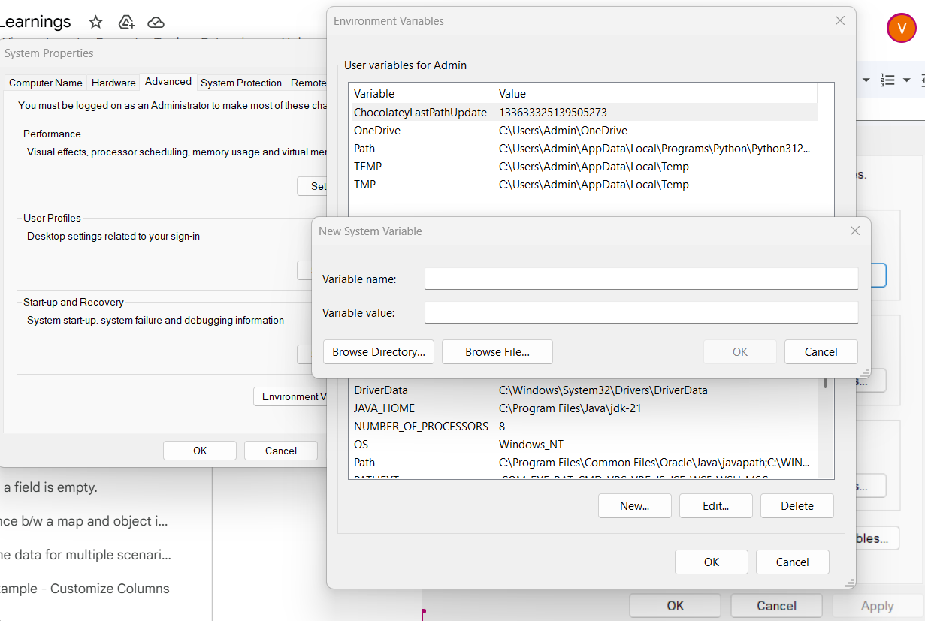
In the variable name, provide “NODE_HOME”.
In variable value, provide the copied value without any quotes - C:\Program Files\nodejs

Click on the OK button and the path is set.

VSCode Installation
After installing Nodejs, we need an editor. The best editor for working on Javascript and Typescript is VSCode. It is completely free and provided by Microsoft.

Search on Google - visual studio code
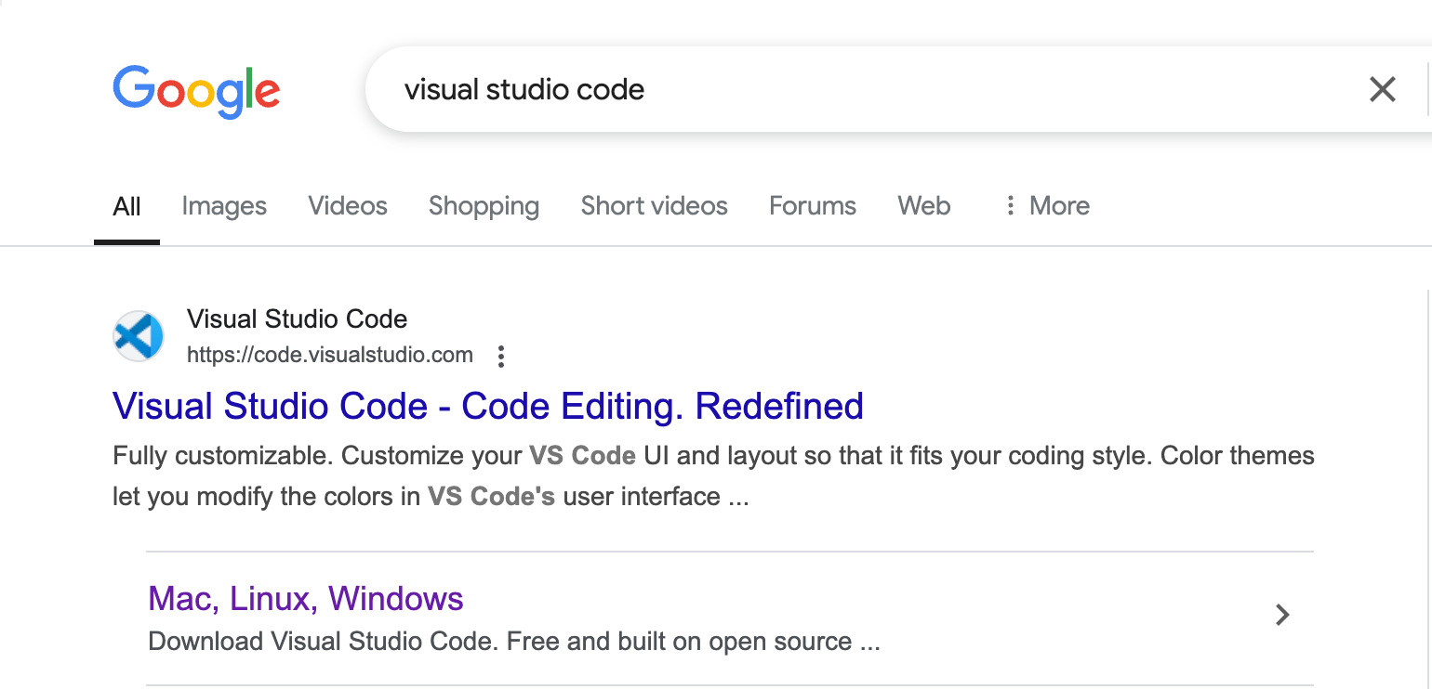
Open the official website.
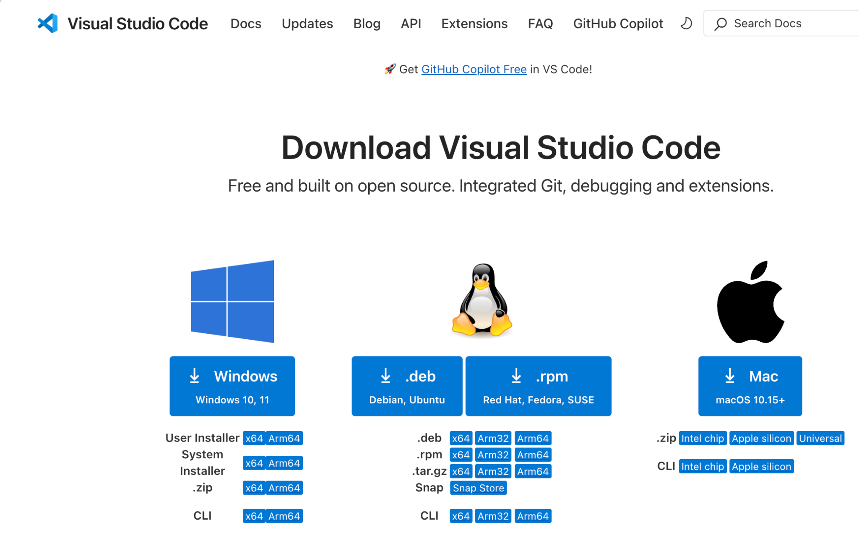
We have these options - User Installer, System Installer, .zip and CLI.
VS Code User Installer (x64) – Recommended
- Best for most users
- Installs only for the current user (no admin rights needed)
- Automatically updates
When to choose other options?
- System Installer (x64)
  - If you want VS Code available for all users on the system
  - Requires admin privileges to install
- .zip (x64)
  - If you don’t want to install VS Code (just extract & run)
  - No auto-updates
- CLI (x64)
  - If you need a portable version for scripting or automation
Which Architecture to Choose?
- x64 → For most modern Windows PCs (Recommended)
- x86 → Only for older 32-bit Windows PCs
- ARM64 → Only if you're using an ARM-based Windows device (like Surface Pro X)
Conclusion: Go with "User Installer (x64)" unless you have specific needs!
After downloading, simply double click and click on Next buttons to install it.
Open VSCode. Create an empty folder anywhere on your computer say "playwright” and open it in VSCode. We can simply drag and drop the folder from Finder to VSCode to open it.
You can increase the font size by pressing Command and + key(MAC) or Control and + key(Windows).
Sometimes you might also see this dialog. If yes, click on the option “Yes, I trust the authors”.
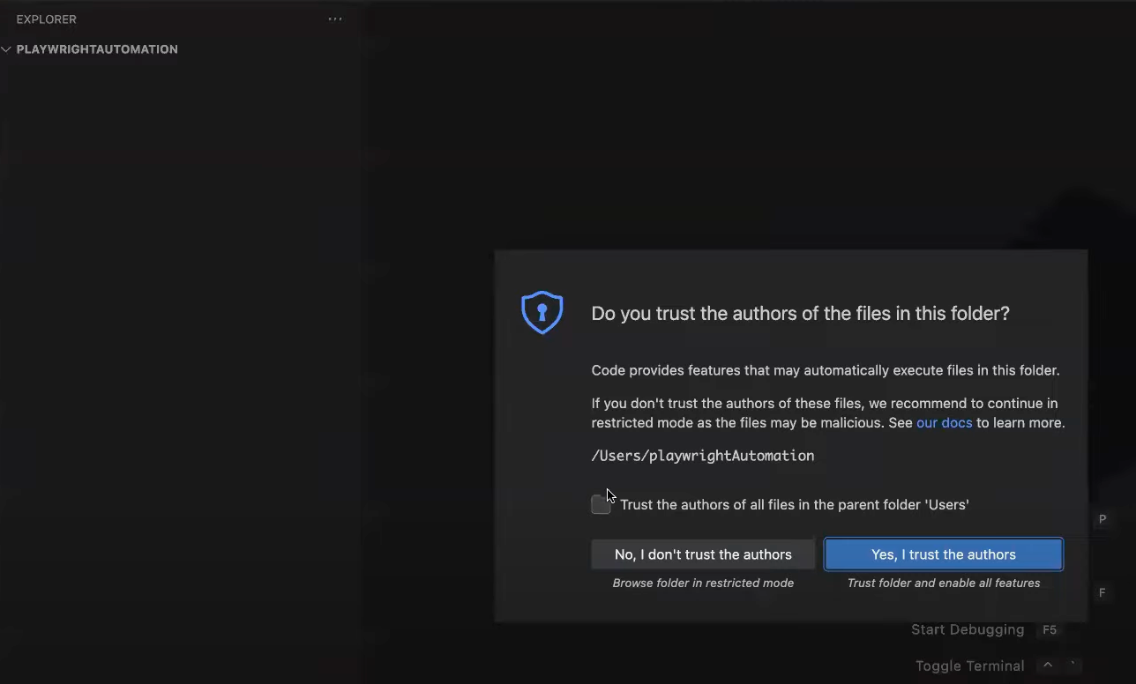
For Playwright, we need one extra extension.

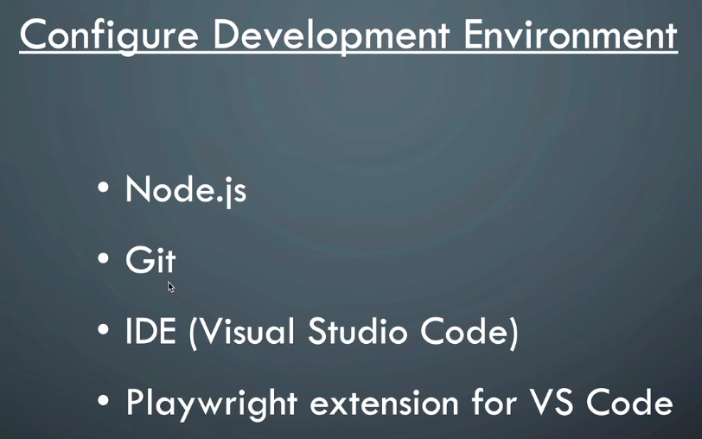

Check the version of npm, node and git.

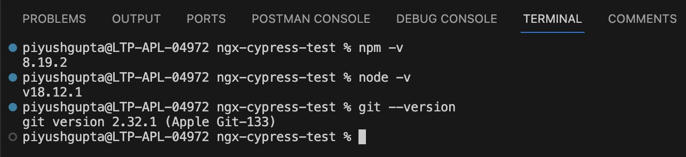

Playwright Installation -
It is clearly mentioned in the documentation how to install Playwright.
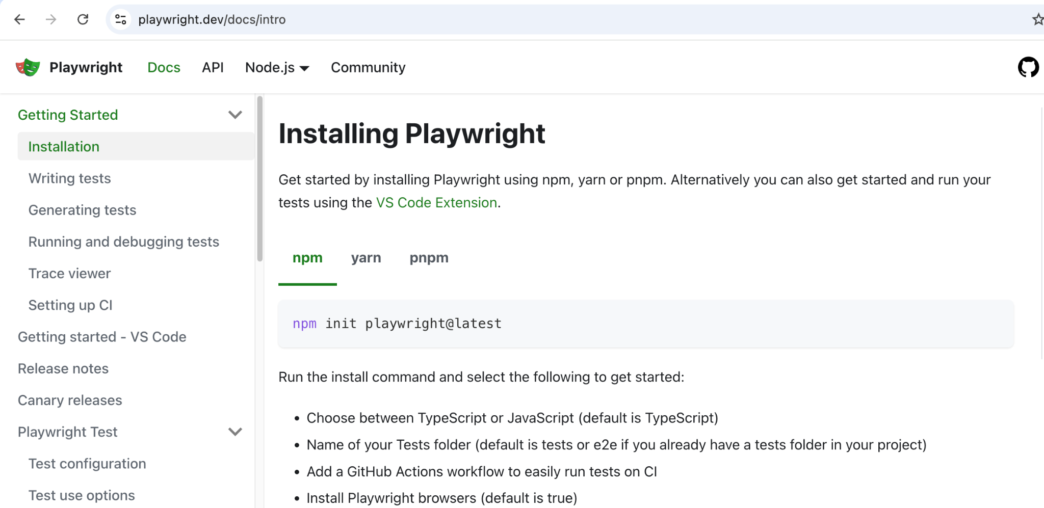
Inside VS Code, open the terminal first by clicking on Terminal > New Terminal option.
Now run this below command.
npm init playwright@latest
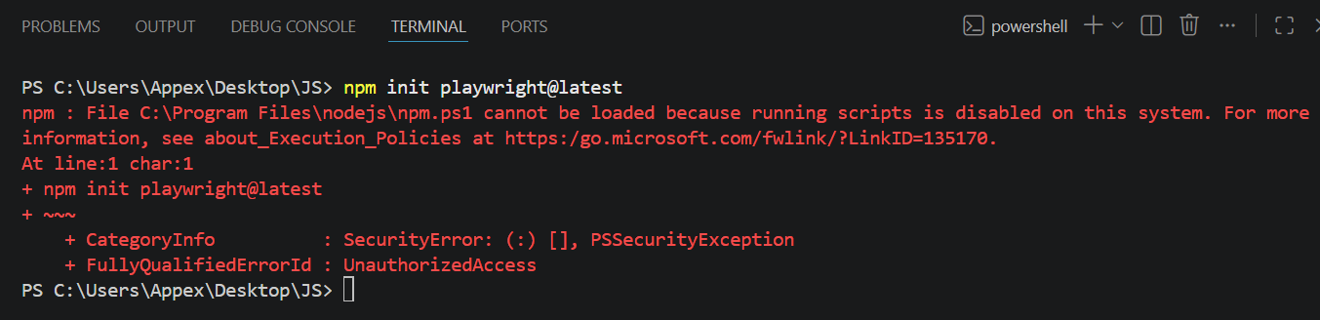
(Only on Windows, not MAC) You may see the above error while installing Playwright
running scripts is disabled on this system
Do not worry. This is a very common issue on Windows. Nothing is wrong with your installation. Windows is just blocking scripts for security reasons.
We need to allow scripts to run once, and then everything will work normally.
Please follow these steps carefully.
Step 1
Close VS Code.
Step 2
Click on the Windows search box and type:
PowerShell
Step 3
Right-click on PowerShell and select:
Run as Administrator
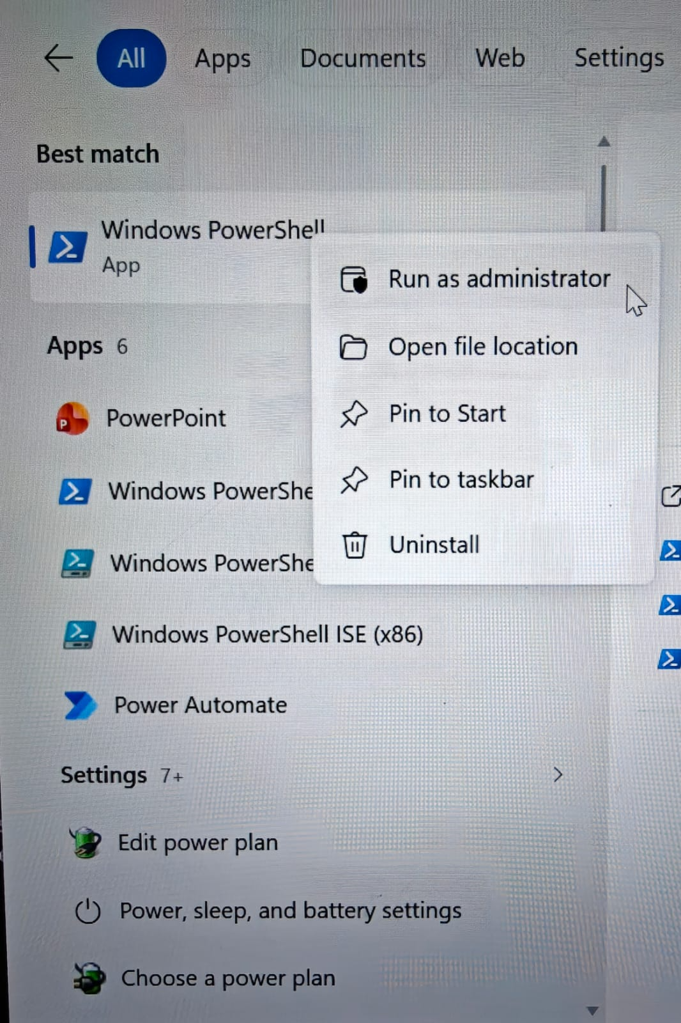
Step 4
In the PowerShell window, type the following command exactly:
Set-ExecutionPolicy RemoteSigned -Scope CurrentUser
Then press Enter.
Step 5
You will see a message asking for confirmation.
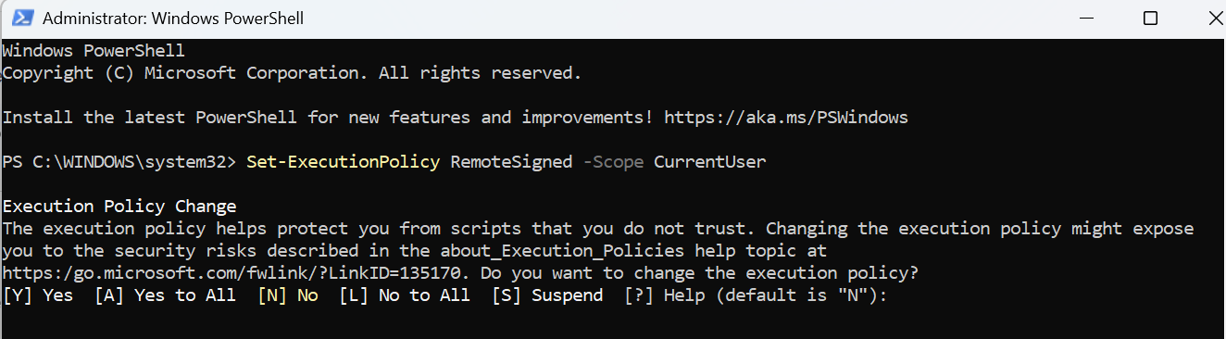
Type:
Y
and press Enter.
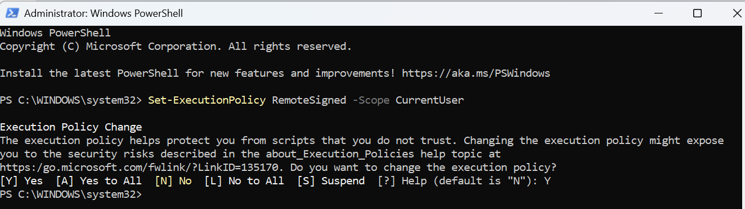
That is it.
Now open VS Code again and run your command:
npm init playwright@latest
Run the command - npm init playwright@latest
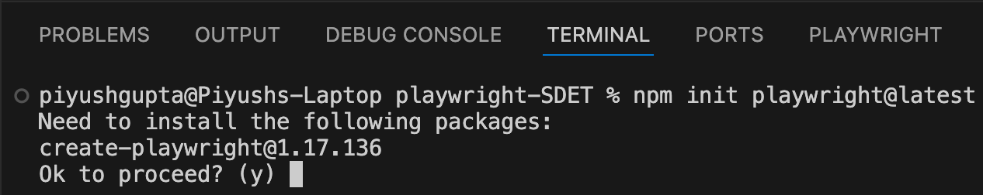
In the latest Playwright version, you might not see this option - selection of Typescript/Javascript and by default, it will take Typescript. Update - Now we will see the below options.
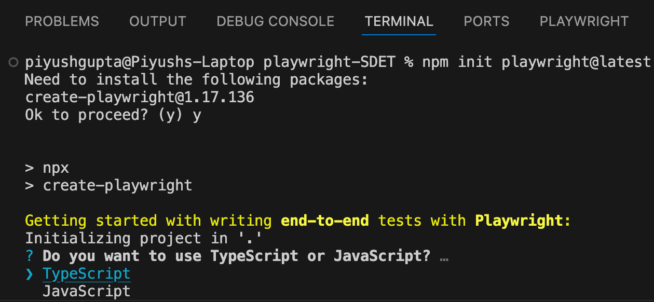
Now select all the other options.
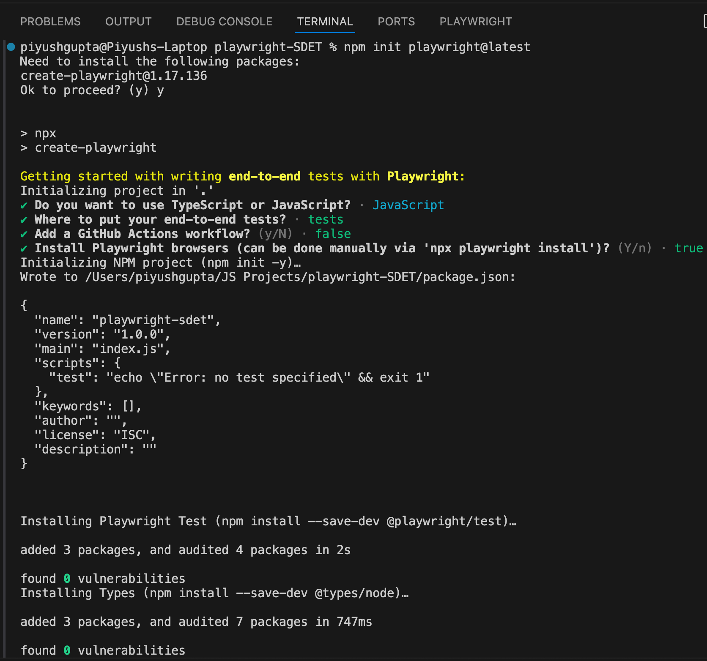
This is the project structure.
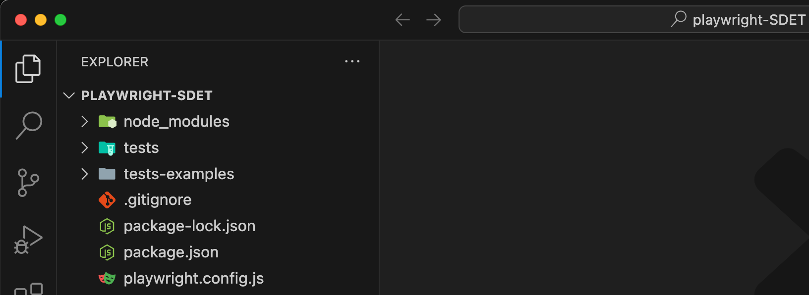
All spec files will be created in the tests folder.
playwright.config.js is the configuration file for Playwright.
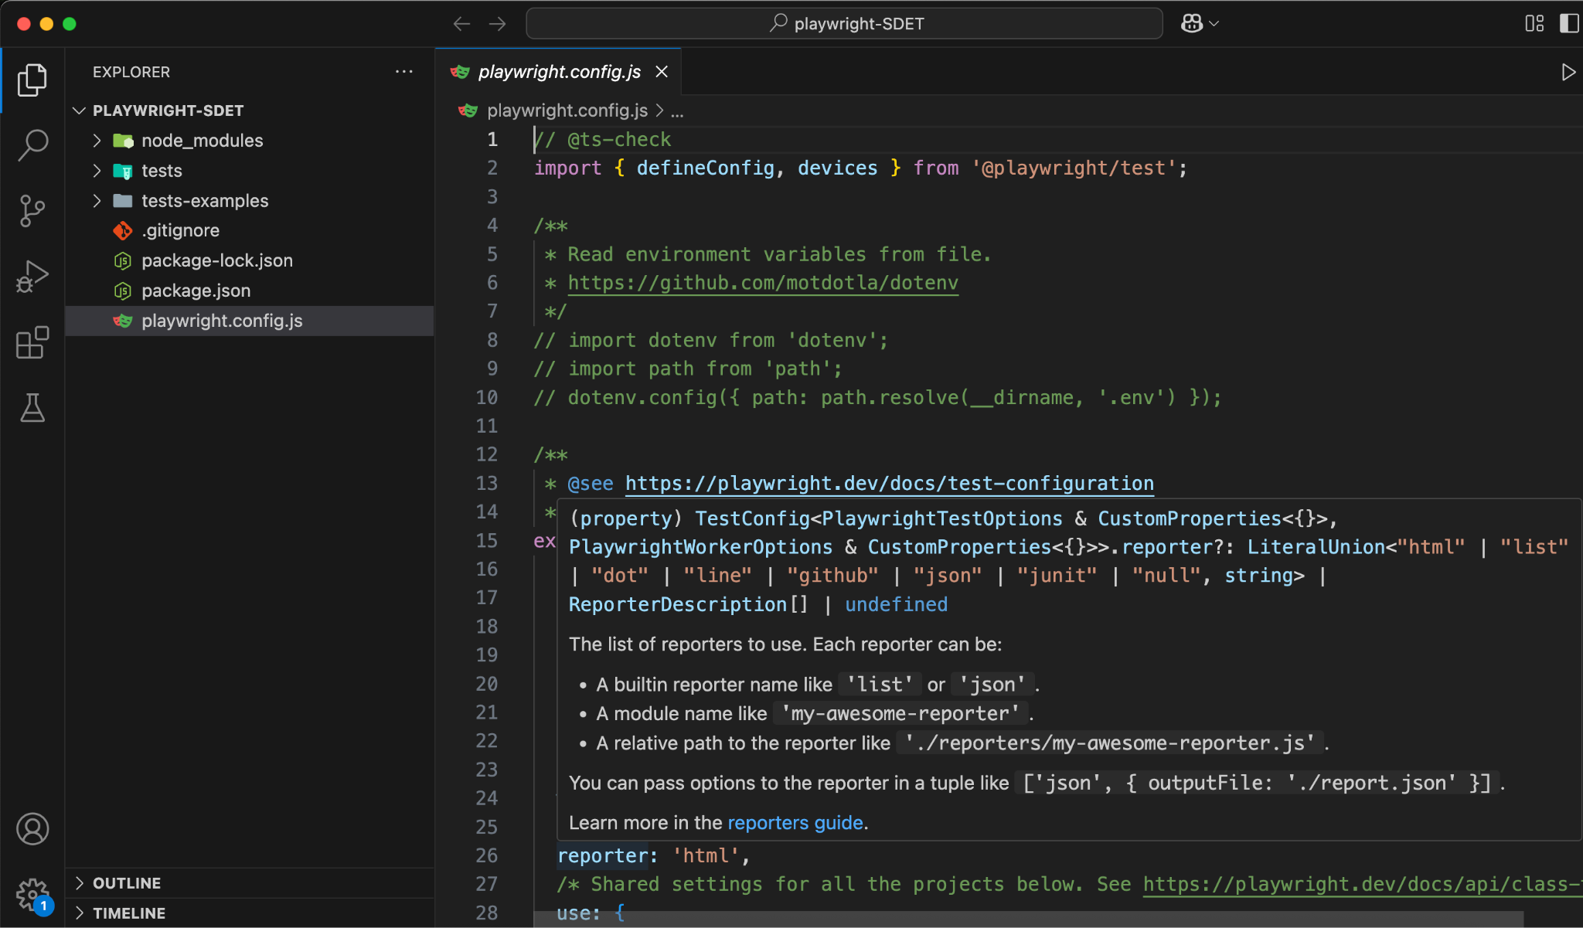
Scroll down to the projects section. We have 3 projects here - chromium, firefox and webkit. So when we run the command - npx playwright test, it will run the tests on all the 3 browsers in parallel.
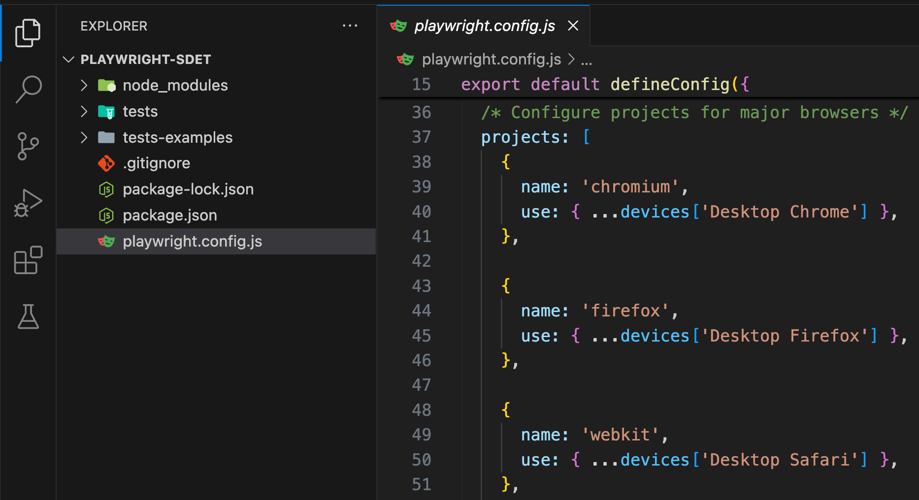
We can modify any Playwright configuration from the playwright.config.js file.
Open Extensions from the left panel and search for “playwright”.
Install this extension.
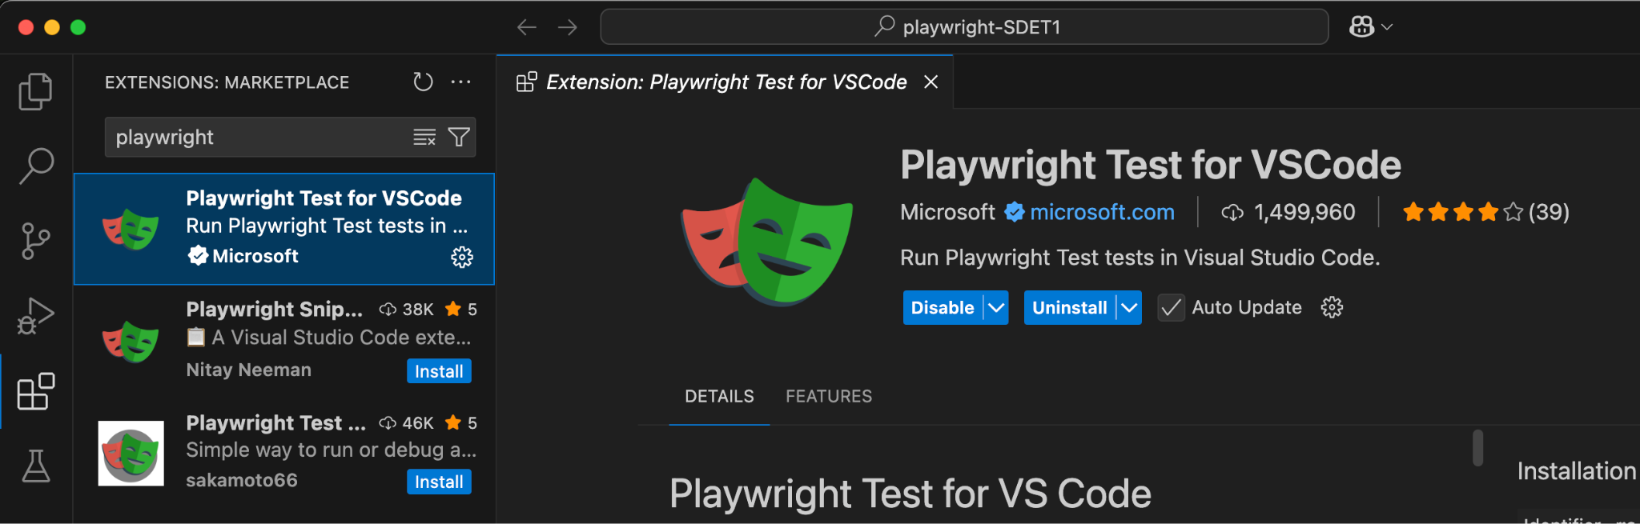
Here is the example.spec.js file.
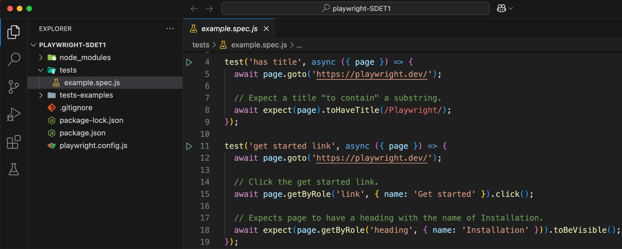
Now run the command - npx playwright test
It will pick all the tests defined in the tests folder as specified in playwright.config.js file.
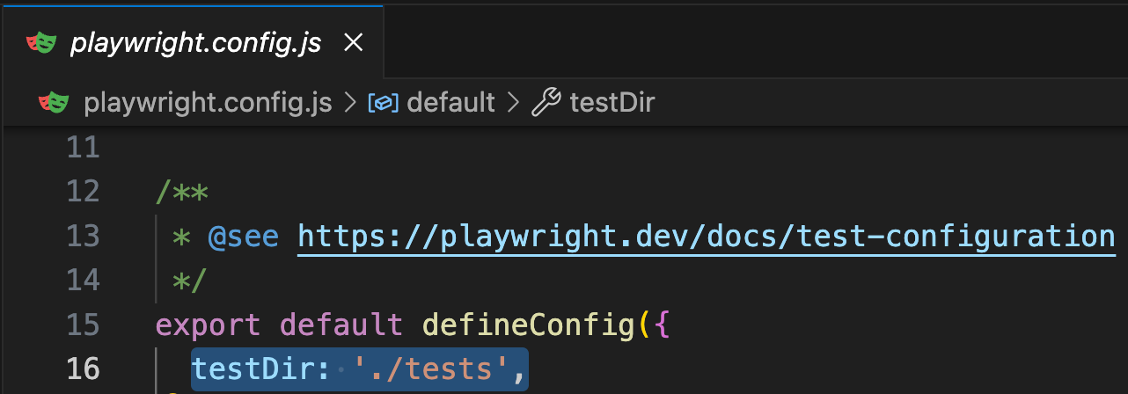
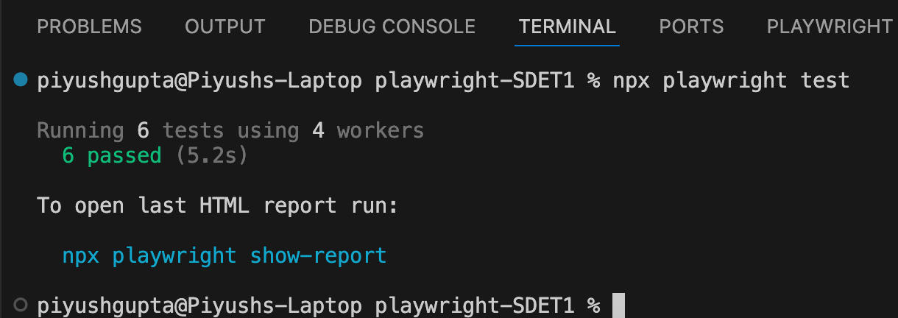
Currently we have 2 tests inside example.spec.js and 3 browsers defined in playwright.config.js inside the projects section. So all these 2 tests ran on these 3 browsers in parallel.
By default, Playwright runs the tests in headless mode. To run them in headed mode, add --headed.
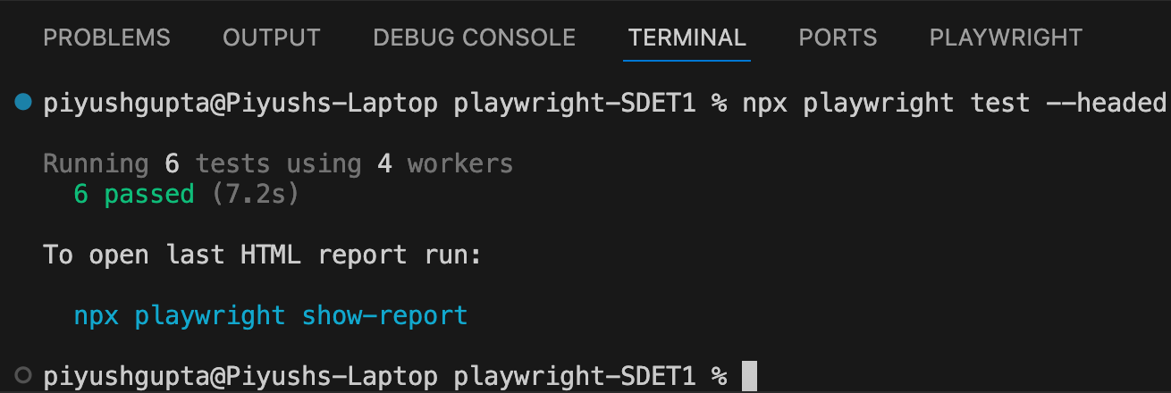
Also, we can see that a HTML report is generated by Playwright but it will be opened automatically only in case of a failure.
Run the command - npx playwright show-report to open the report.
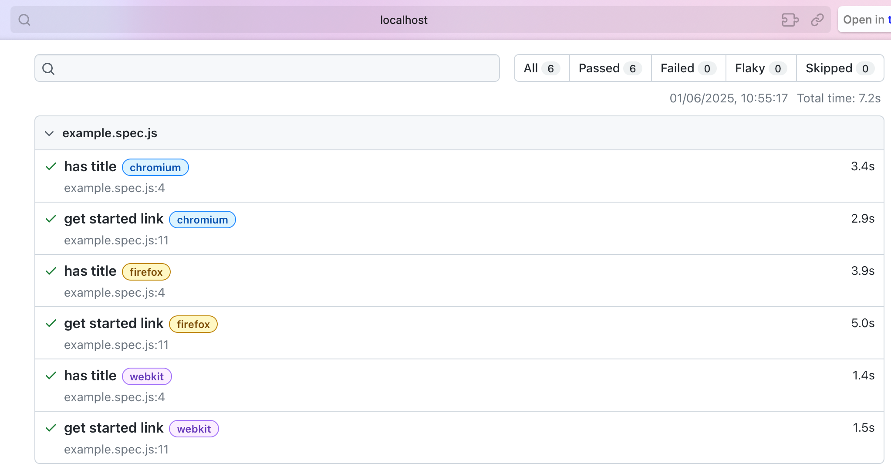
First 2 tests are executed in chromium, then next 2 in firefox and last 2 in webkit.

